LAB Logbook
Name: Chunmika Rajaboina
SID: 2441355

WEEK 1
LAB 1:
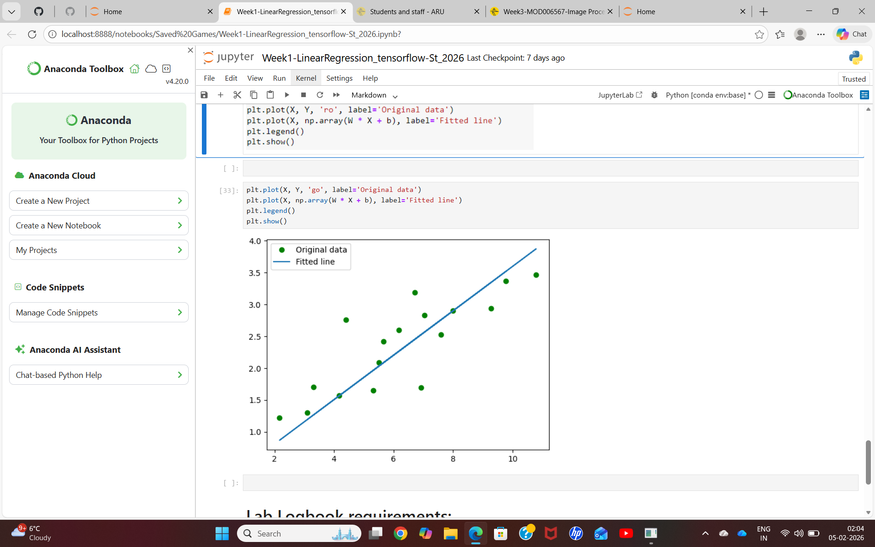

WEEK 2
LAB 2:
Model’s test accuracy is 0.930
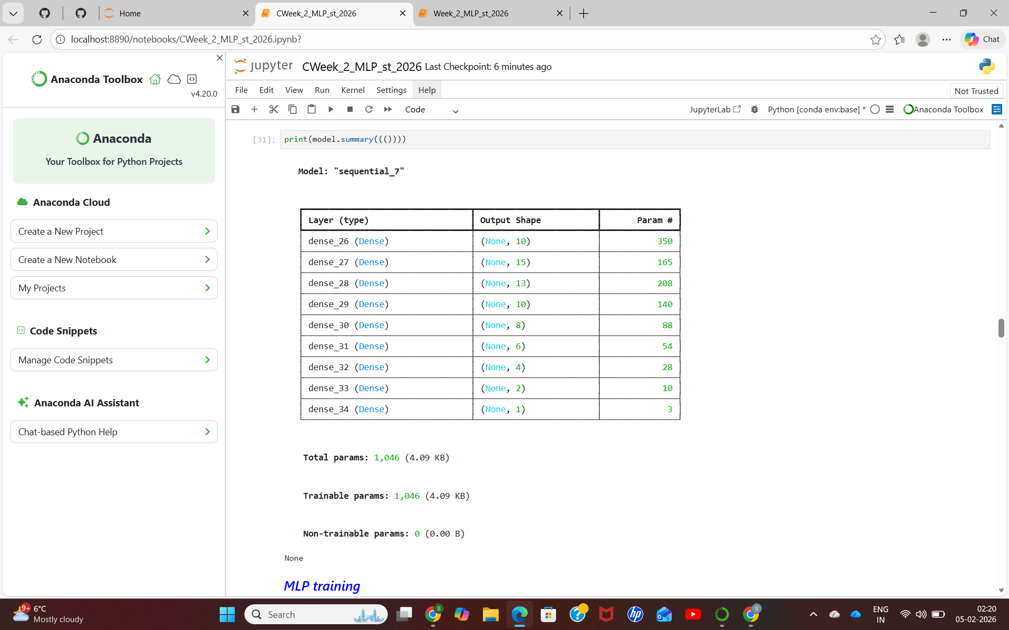

WEEK 3
LAB 3:
Test accuracy: 0.8950999975204468
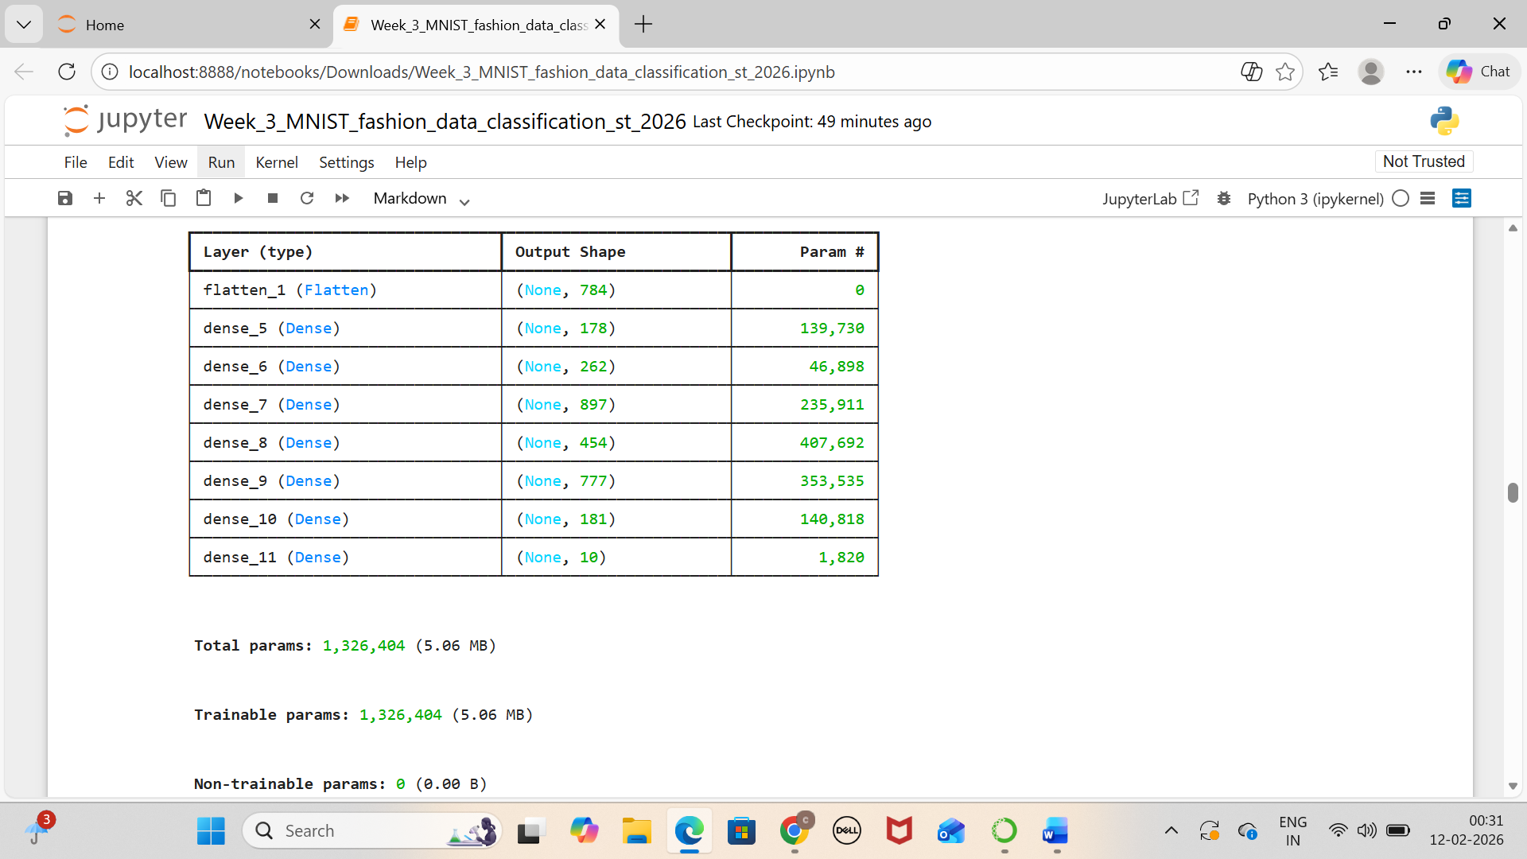

WEEK 4
LAB 4:
